**Question 1:**

**“Renewable Energy Sources”**

**What is renewable energy?**

Renewable energy is energy that comes from a source that won’t run out. They are natural and self-replenishing, and usually have a low- or zero-carbon footprint.

Examples of renewable energy sources include wind power, solar power, bioenergy (organic matter burned as a fuel) and hydroelectric, including tidal energy.

Burning fossil fuels to create electricity has long been a major contributor in the emission of [**greenhouse gases**](https://www.nationalgrid.com/stories/energy-explained/what-are-greenhouse-gases) into our atmosphere, so these renewable sources are considered vital in the race to tackle climate change.

**The most common renewable energy sources**

In the UK, there are four main sources of renewable energy:

**Wind**

Wind power is the largest producer of renewable electricity in both the UK and the US. [**Onshore and offshore wind farms**](https://www.nationalgrid.com/stories/energy-explained/onshore-vs-offshore-wind-energy) generate electricity by spinning the blades of [**wind turbines**](https://www.nationalgrid.com/stories/energy-explained/how-does-wind-turbine-work). The turbines convert the kinetic energy of the spinning blades into electric energy by turning a drive shaft and gear box, which is connected to a generator. Electricity is then converted into higher voltages and fed into the national grid.

**Solar**

Sunlight is one of the planet’s most freely available energy resources, which you’d assume would make it the number one source of renewable energy. But of course, the amount of sunlight we get can vary greatly depending on location, season and time of day.

[**Solar power**](https://www.nationalgrid.com/stories/energy-explained/how-does-solar-power-work) generates electricity by capturing sunlight on solar panels in a joint chemical and physical reaction, known as the ‘photovoltaic effect’ (or PV).

**Hydroelectric**

Hydro power is created using the movement of flowing or falling water. Hydroelectric power plants are found at dams and generate electricity through underwater turbines that turn a generator. Hydro power also encompasses wave and tidal power, which rely on ocean forces to generate electricity at the mouths of large bodies of water, using similar technology.

**Bioenergy**

Electricity can be generated when [**organic matter is burned as a fuel source**](https://www.nationalgrid.com/stories/energy-explained/what-is-biogas). These fuels are known as biomass and include anything from plants to timber to food waste. Carbon dioxide (CO2) is emitted when bioenergy is made, but these fuel sources are considered renewable because they can be regrown and absorb as much carbon as they emit across their lifespans.

**Question 2:**

|  |  |  |  |  |  |  |  |
| --- | --- | --- | --- | --- | --- | --- | --- |
| **DAYS** | **TIME TABLE** | | | | | | |
| **10.00AM TO**  **11.00AM** | **11.00AM**  **TO**  **12.00AM** | **12.00AM**  **TO**  **1.00PM** | **LUNCH BREAK** | **2.00PM**  **TO**  **3.00PM** | **3.00PM**  **TO**  **4.00PM** | **4.00PM**  **TO**  **5.00PM** |
| MONDAY | ENGLISH | SCIENCE | TELUGU | GK | SOCIAL | PHYSICS |
| TUESDAY |
| WEDNESDAY |
| THURSDAY | MATHS | HINDI | MATHS | CHEMISTRY |
| FRIDAY |
| SATURDAY |

**Question 3:**

**“Renewable Energy Sources”**

**What is renewable energy?**

Renewable energy is energy that comes from a source that won’t run out. They are natural and self-replenishing, and usually have a low- or zero-carbon footprint.

Examples of renewable energy sources include wind power, solar power, bioenergy (organic matter burned as a fuel) and hydroelectric, including tidal energy.

Burning fossil fuels to create electricity has long been a major contributor in the emission of [**greenhouse gases**](https://www.nationalgrid.com/stories/energy-explained/what-are-greenhouse-gases) into our atmosphere, so these renewable sources are considered vital in the race to tackle climate change.

**The most common renewable energy sources**

In the UK, there are four main sources of renewable energy:

**Wind**

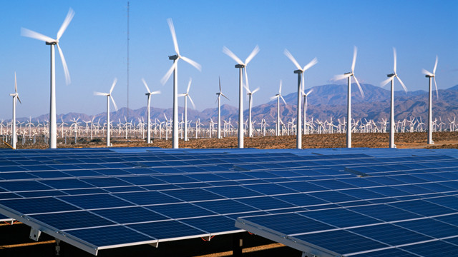Wind power is the largest producer of renewable electricity in both the UK and the US. [**Onshore and offshore wind farms**](https://www.nationalgrid.com/stories/energy-explained/onshore-vs-offshore-wind-energy) generate electricity by spinning the blades of [**wind turbines**](https://www.nationalgrid.com/stories/energy-explained/how-does-wind-turbine-work). The turbines convert the kinetic energy of the spinning blades into electric energy by turning a drive shaft and gear box, which is connected to a generator. Electricity is then converted into higher voltages and fed into the national grid.

**Solar**

Sunlight is one of the planet’s most freely available energy resources, which you’d assume would make it the number one source of renewable energy. But of course, the amount of sunlight we get can vary greatly depending on location, season and time of day.

[**Solar power**](https://www.nationalgrid.com/stories/energy-explained/how-does-solar-power-work) generates electricity by capturing sunlight on solar panels in a joint chemical and physical reaction, known as the ‘photovoltaic effect’ (or PV).

**Hydroelectric**

Hydro power is created using the movement of flowing or falling water. Hydroelectric power plants are found at dams and generate electricity through underwater turbines that turn a generator. Hydro power also encompasses wave and tidal power, which rely on ocean forces to generate electricity at the mouths of large bodies of water, using similar technology.

**Bioenergy**

Electricity can be generated when [**organic matter is burned as a fuel source**](https://www.nationalgrid.com/stories/energy-explained/what-is-biogas). These fuels are known as biomass and include anything from plants to timber to food waste. Carbon dioxide (CO2) is emitted when bioenergy is made, but these fuel sources are considered renewable because they can be regrown and absorb as much carbon as they emit across their lifespans.